CSIT314 Software Development Methodologies - Group Project

Sprint 2 - US16: Update company profile
Interior Design Platform - Interior Designer
All diagrams were drawn in draw.io. Open "US16 Update company profile.drawio" in this folder to edit them - each diagram is its own page in that file. The exported images are in the "diagrams" folder.

Assumptions
- The system is the Interior Design Platform from the project specification. Sprint 2 covers the Interior Designer's stories (log in, company profile and log out, US13 - US19) and the Platform Manager's log in (US39).
- We follow B-C-E: the actor only talks to the boundary (page), the boundary only talks to the controller, and the controller works with the entity classes. There is one controller per use case.
- The update uses the same field rules as US14 (CreateCompanyProfileController.getFieldErrors() is reused), so create and update can never have different rules.
- Only the six business fields change. companyId, designerId and createdDate stay the same, and no new row is added.
- Optional fields (email, phone, address) can be cleared by leaving them empty.
- A designer can only use their own company profile. The owner always comes from the logged-in session, so a designerId or companyId put in the URL or the form is ignored.
- If the designer has no company profile, the update page shows "You have not created a company profile yet" (HTTP 404). An update never creates a profile.
- Every designer page checks access again from the database (InteriorDesignerLoginController.getAuthenticatedDesigner() from US13). Someone who is not logged in is sent to the designer login page. Anyone else without designer access (e.g. a User Admin, or a designer suspended after logging in) gets "Access unavailable" (HTTP 403).

1. User story
Story ID | US16
User story | As an interior designer, I want to update my company profile so that customers see the latest information.
Actor | Interior Designer
Priority | Medium
Story points (estimate) | 3
Acceptance criteria | 1. Given I am viewing my company profile, there is an "Update company profile" button that opens the form filled in with my saved details.  2. Given I change the details correctly and click "Save changes", then the profile is updated, I go back to my company profile and see "Company profile updated successfully".  3. Given a required field is empty, a field is too long or the email isn't valid, then I see "Please fix the highlighted fields", what I typed is kept and the saved profile is not changed.  4. Given I click "Cancel", then I go back to my company profile and nothing is changed.  5. Given I have no company profile, then I see "You have not created a company profile yet".
Tasks | T16.1 Write the use case description and draw the use case diagram  T16.2 Draw the B-C-E class diagram and the sequence diagram  T16.3 Draw the wireframes for the update button, the form, the errors, the success message and profile not found  T16.4 Write the unit tests first (TDD) for CompanyProfile.updateCompanyProfile(), UpdateCompanyProfileController and UpdateCompanyProfilePage  T16.5 Code CompanyProfile.updateCompanyProfile() (only the owner's row, only the six fields)  T16.6 Code UpdateCompanyProfileController, reusing the US14 field rules  T16.7 Code UpdateCompanyProfilePage, the update form and the "Update company profile" button on the view page  T16.8 Run the test cases, fix bugs and push to the repo so the CI pipeline runs the unit tests

2. Use case diagram
The user story becomes one use case, UC16 Update company profile. The Interior Designer is the only actor.
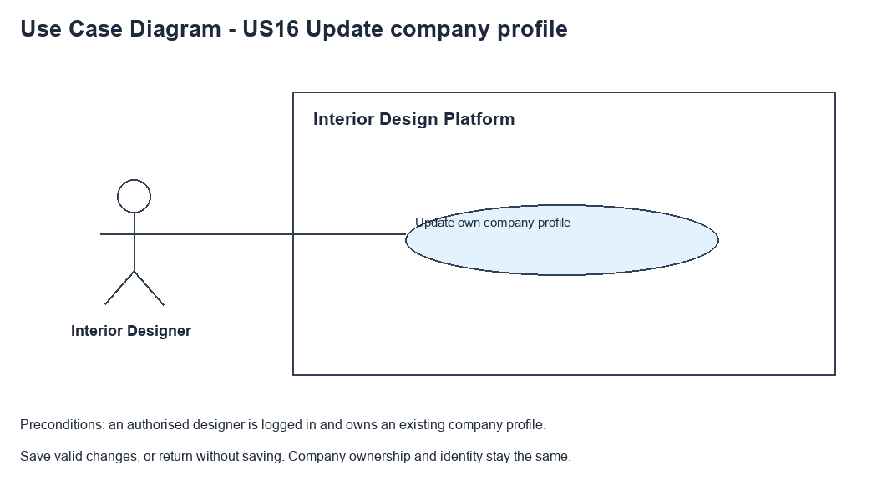
Figure 1: Use case diagram for US16 Update company profile

3. Use case description
Use case | UC16 Update company profile
Actor | Interior Designer
Brief description | The Interior Designer changes their company profile so customers see the latest information.
User story | US16: As an interior designer, I want to update my company profile so that customers see the latest information.
Preconditions | The Interior Designer is logged in (UC13).  The designer has a company profile (UC14).
Trigger | The Interior Designer clicks "Update company profile" on the company profile page (UC15).
Basic flow | 1. The Interior Designer clicks "Update company profile".  2. The system checks the designer's access and loads their company profile.  3. The system shows the form filled in with the saved details.  4. The Interior Designer changes the details and clicks "Save changes".  5. The system checks the access again and checks the fields (same rules as UC14).  6. The system updates the designer's company profile.  7. The system shows the company profile with "Company profile updated successfully".
Alternative flows | 2a. The designer has no company profile: the system shows "You have not created a company profile yet" (HTTP 404). The use case ends.  4a. The Interior Designer clicks "Cancel": the system goes back to the company profile. Nothing is saved.  5a. A field is wrong: the system shows "Please fix the highlighted fields" and keeps what was typed. The saved profile is not changed. Back to step 4.  6a. The profile was deleted in the meantime: the system shows "You have not created a company profile yet" and doesn't create a new one. If the save fails for another reason, the system shows "Company profile could not be updated. Please try again".
Postconditions | The company profile has the new details.  companyId, owner and created date are the same as before.

4. Wireframes
The wireframes were drawn in draw.io. They are low-fidelity: they show the layout and the flow, not the final colours. The orange numbers match the notes under each screen.

4a - Update button
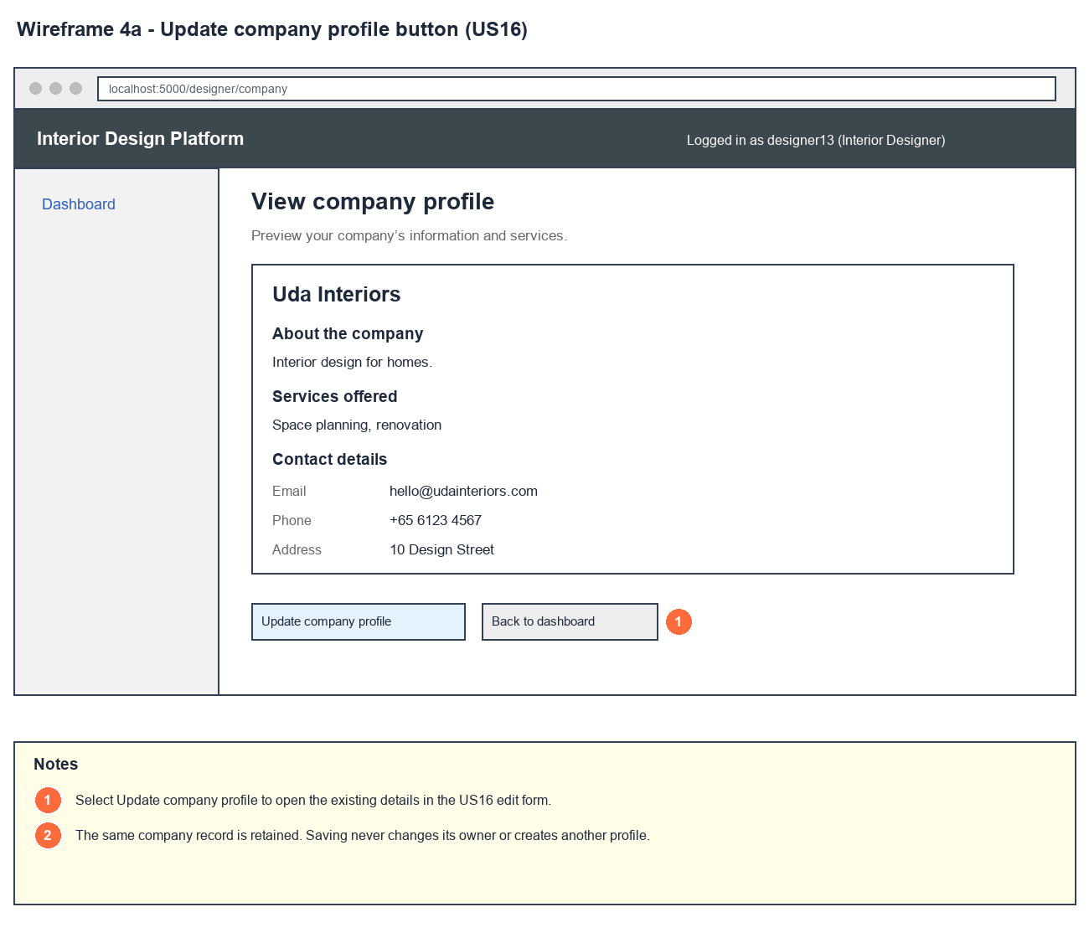
Figure 2: Wireframe 4a - Update button (US16)

4b - Update form
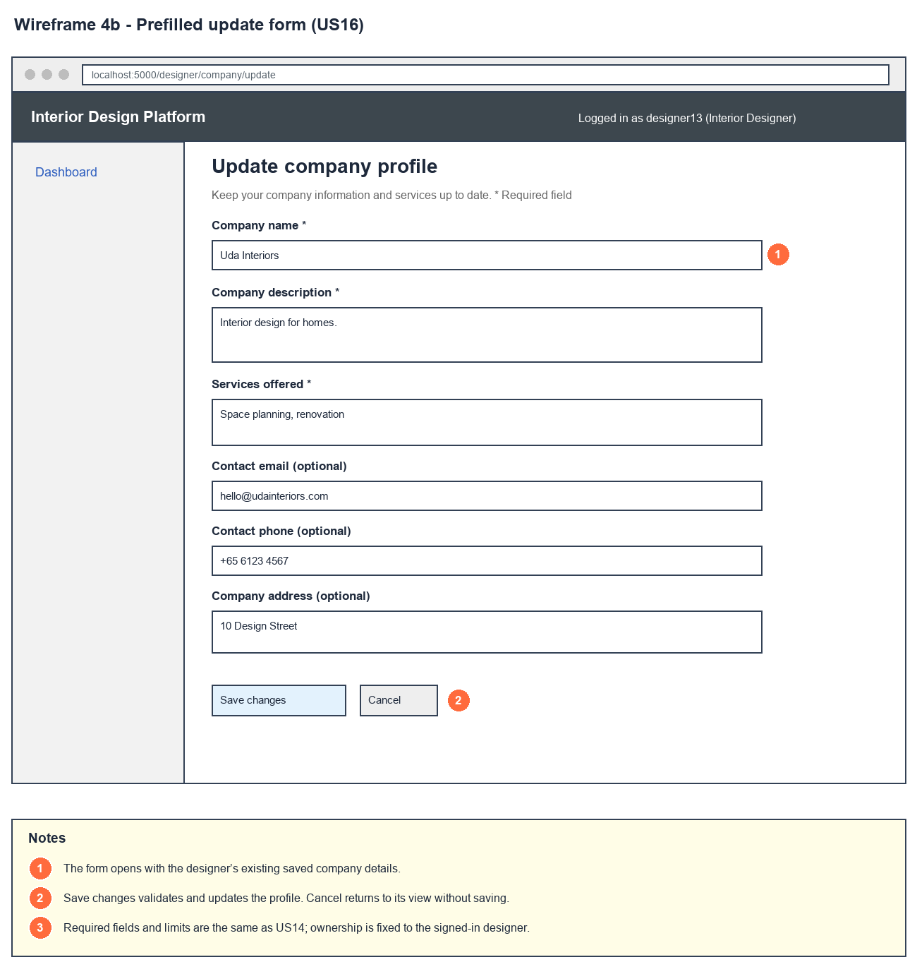
Figure 3: Wireframe 4b - Update form (US16)

4c - Update errors
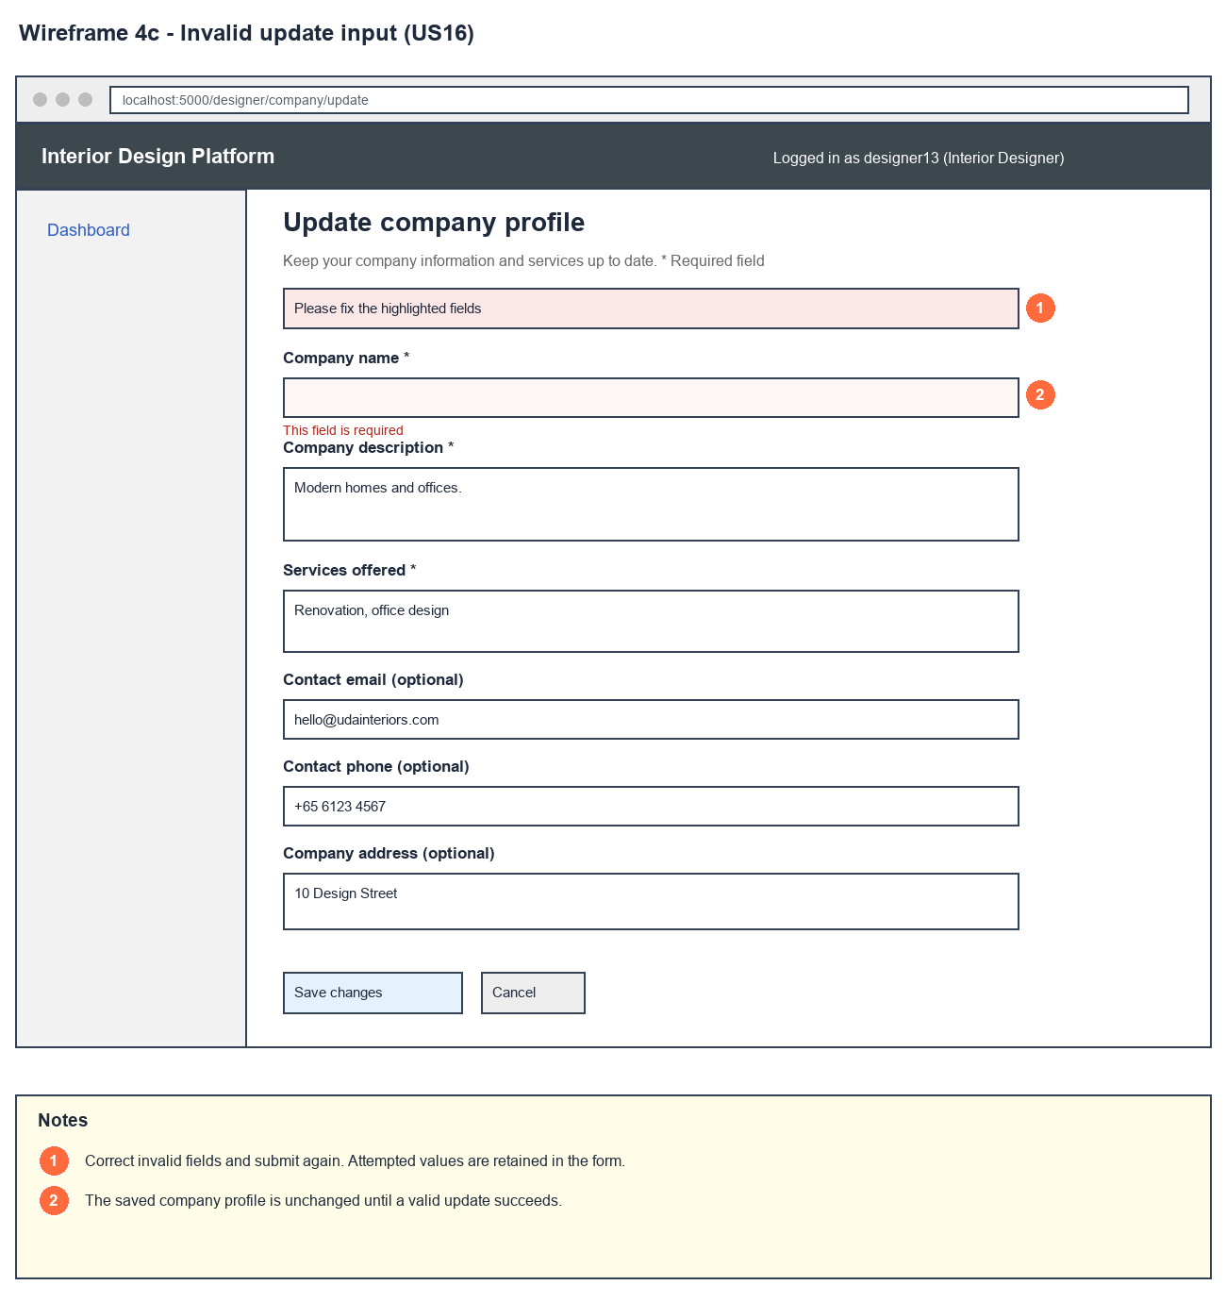
Figure 4: Wireframe 4c - Update errors (US16)

4d - Company updated
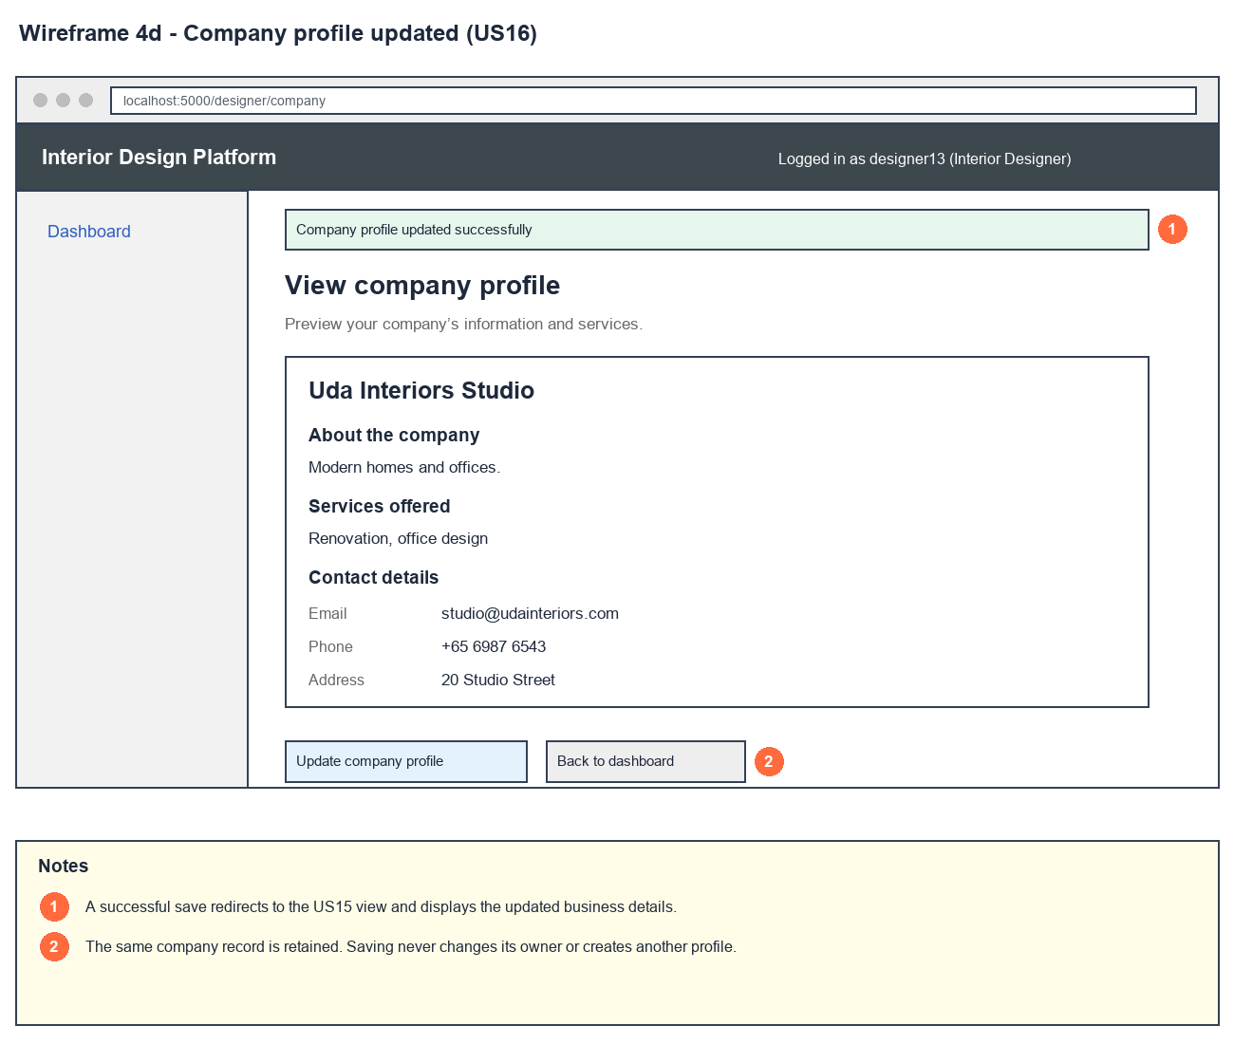
Figure 5: Wireframe 4d - Company updated (US16)

4e - Profile not found
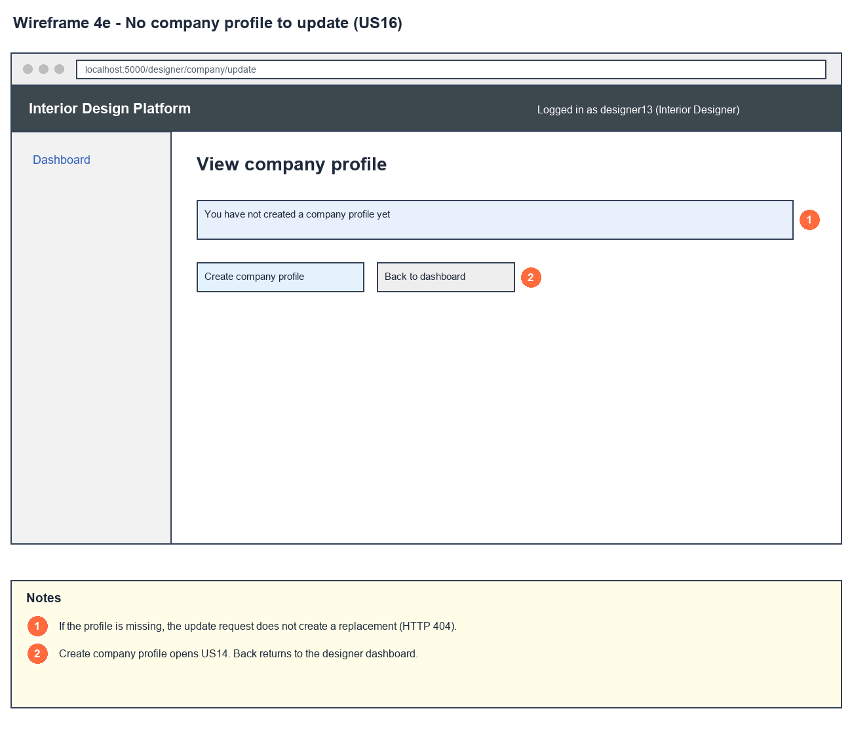
Figure 6: Wireframe 4e - Profile not found (US16)

5. B-C-E class diagram
The solid line means the boundary calls the controller. The dashed lines mean the controller uses the other classes. Only the operations needed for this use case are shown.
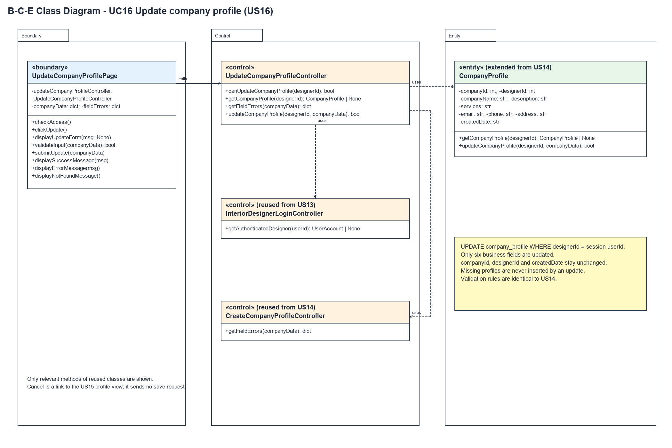
Figure 7: B-C-E class diagram for US16 Update company profile
Layer | Class | What it does
Boundary | UpdateCompanyProfilePage | The update form. clickUpdate() checks access and fills the form with the saved profile. submitUpdate() checks access, validates the input, takes the owner from the session and shows the success, error or not-found message.
Control | UpdateCompanyProfileController | Controller for UC16. canUpdateCompanyProfile() checks access, getCompanyProfile() loads the profile and updateCompanyProfile() checks access and fields again before asking CompanyProfile to save.
Control | InteriorDesignerLoginController (from US13) | getAuthenticatedDesigner() checks the account and profile are Active and have the designer permissions.
Control | CreateCompanyProfileController (from US14) | getFieldErrors() - the same field rules as creating a profile.
Entity | CompanyProfile | Extended from US14 with updateCompanyProfile(), which updates only the six business fields of the owner's row. It returns false if no row was changed, so it never inserts a profile.

6. Sequence diagram
The sequence diagram follows UC16 from when "Save changes" is clicked (opening the form is written at the top of the diagram). The page checks access through the controller (step 5) and validates the input with the US14 rules. The outer alt splits invalid input (alternative flow 5a) from valid input. For valid input the controller checks again and asks CompanyProfile to update the row (step 6). The next alt shows the success message (step 7). If nothing was updated, the page reads the profile again: the inner alt shows the not-found page or the "could not be updated" message (alternative flow 6a).
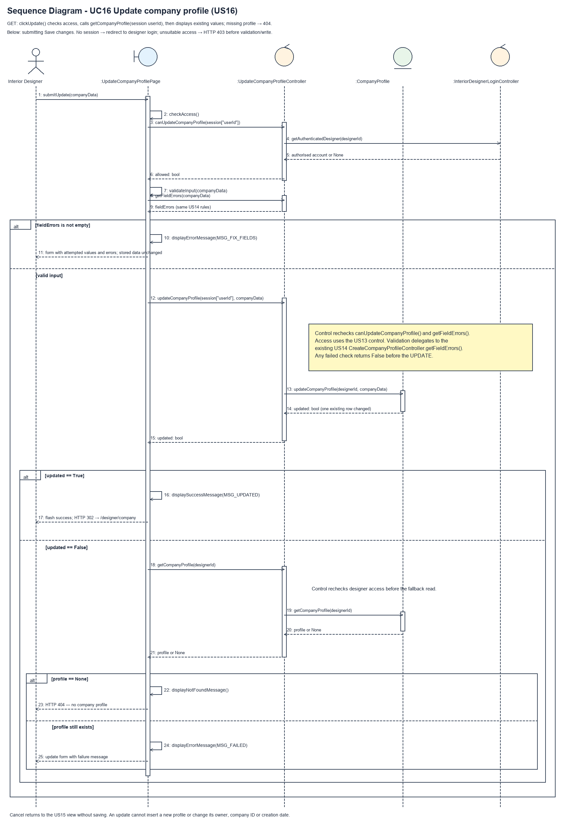
Figure 8: Sequence diagram for UC16 Update company profile

7. Test cases
Test data used below (same as database/seedData.py and the test files): user profiles User Admin (id 1), Interior Designer (id 2), Customer (id 3) and Platform Manager (id 4), all Active. User accounts admin01 / Admin@123 (User Admin) and cust001 / Cust@123 (Customer). The designer account designer13 / Design@123 (Tengku Uda Designer, Interior Designer profile) is made first with UC8. Company data: Uda Interiors, "Interior design for homes.", "Space planning, renovation", hello@udainteriors.com, +65 6123 4567, 10 Design Street. designer13 already has this company profile.

7a. System test cases (black box)
Equivalence partitioning and boundary value analysis were used to pick the test data. Fill in "Actual result" and "Pass/Fail" after running each test.
Test ID | Scenario | Prerequisites | Test steps | Test data | Expected result | Actual result | Pass / Fail
TC16.1 | Update with valid details | Logged in as designer13. Has a company profile. | 1. Open the company profile  2. Click "Update company profile"  3. Change all the fields  4. Click "Save changes" | Uda Interiors Studio, Modern homes and offices., Renovation, office design, studio@udainteriors.com, +65 6987 6543, 20 Studio Street | "Company profile updated successfully" and the new details are shown.
TC16.2 | Form shows the saved details | Logged in as designer13. Has a company profile. | 1. Click "Update company profile" | - | Every field is filled in with the saved value.
TC16.3 | Clear the optional fields | Logged in as designer13. Has a company profile. | 1. Click "Update company profile"  2. Clear email, phone and address  3. Click "Save changes" | (empty) email, phone, address | "Company profile updated successfully". Those fields show "Not provided".
TC16.4 | Required field empty | Logged in as designer13. Has a company profile. | 1. Click "Update company profile"  2. Clear the company name  3. Click "Save changes" | (empty) company name | "Please fix the highlighted fields". The typed values are kept. The saved profile is unchanged.
TC16.5 | Invalid email | Logged in as designer13. Has a company profile. | 1. Click "Update company profile"  2. Type an invalid email  3. Click "Save changes" | not-an-email | "Enter a valid email address". The saved email is still hello@udainteriors.com.
TC16.6 | Company name too long | Logged in as designer13. Has a company profile. | 1. Click "Update company profile"  2. Type a 101-character name  3. Click "Save changes" | 101 x "A" | "Maximum 100 characters". The saved profile is unchanged.
TC16.7 | Cancel | Logged in as designer13. Has a company profile. | 1. Click "Update company profile"  2. Change the name  3. Click "Cancel" | Changed Name | Back on the company profile. The name is still Uda Interiors.
TC16.8 | No company profile | Logged in as designer13. No company profile. | 1. Open /designer/company/update | - | "You have not created a company profile yet" (HTTP 404).

7b. Unit test cases (for TDD)
These are written before the code (test-driven development) and run automatically in the CI pipeline. They cover normal inputs, abnormal inputs and boundary values. Each one matches a test function in tests/test_us16_updateCompanyProfile.py (e.g. UT16.1 is test_ut16_1_...). Pass / Fail is from the pytest run on 23 October 2026.
Test ID | Class and method | Input / setup | Expected output | Type | Pass / Fail
UT16.1 | UpdateCompanyProfileController.updateCompanyProfile() | designer13, the updated data | Returns true. All six fields have the new values | Normal | Pass
UT16.2 | UpdateCompanyProfileController.updateCompanyProfile() | designer13, the updated data | companyId, designerId and createdDate unchanged. Still one row | Normal | Pass
UT16.3 | UpdateCompanyProfileController.updateCompanyProfile() | designer13 with no profile | Returns false. No row added | Abnormal | Pass
UT16.4 | UpdateCompanyProfileController.updateCompanyProfile() | userId 1 (User Admin) | Returns false. Data unchanged | Abnormal | Pass
UT16.5 | UpdateCompanyProfileController.updateCompanyProfile() | userId 9999 | Returns false | Abnormal | Pass
UT16.6 | UpdateCompanyProfileController.updateCompanyProfile() | services = " " | Returns false. Data unchanged | Boundary | Pass
UT16.7 | UpdateCompanyProfileController.updateCompanyProfile() | email = "not-an-email" | Returns false. Email still hello@udainteriors.com | Abnormal | Pass
UT16.8 | UpdateCompanyProfileController.updateCompanyProfile() | email, phone and address empty | Returns true. Those fields are now empty | Normal | Pass
UT16.9 | UpdateCompanyProfileController.updateCompanyProfile() | companyName = " Uda Interiors Studio " | Returns true. Saved as "Uda Interiors Studio" | Boundary | Pass
UT16.10 | UpdateCompanyProfileController.updateCompanyProfile() | designer13 with the account suspended | Returns false | Abnormal | Pass
UT16.11 | CompanyProfile.updateCompanyProfile() | designer13 updates; designer16 also has a profile | Only designer13's row changes | Normal | Pass
UT16.12 | CompanyProfile.updateCompanyProfile() | designerId 9999 | Returns false. No row added | Abnormal | Pass
UT16.13 | CompanyProfile.updateCompanyProfile() | description = "" (bypassing the controller) | Returns false. Database check rolls back, data unchanged | Abnormal | Pass
UT16.14 | UpdateCompanyProfilePage.validateInput() | Valid updated data | Returns true | Normal | Pass
UT16.15 | UpdateCompanyProfilePage.validateInput() | companyName = "" | Returns false. fieldErrors has companyName | Boundary | Pass
UT16.16 | UpdateCompanyProfilePage.validateInput() | companyName = 101 x "A" | Returns false | Boundary | Pass
UT16.17 | UpdateCompanyProfilePage.clickUpdate() | GET /designer/company/update | Form filled in with the saved values and a "Save changes" button | Normal | Pass
UT16.18 | UpdateCompanyProfilePage.submitUpdate() | POST the updated data | Redirects to /designer/company with "Company profile updated successfully" and the new details | Normal | Pass
UT16.19 | UpdateCompanyProfilePage.submitUpdate() | POST with companyName empty | "Please fix the highlighted fields". Typed values kept. Data unchanged | Abnormal | Pass
UT16.20 | Cancel link on the update form | Open the form, then go back | Cancel links to /designer/company. Data unchanged | Normal | Pass
UT16.21 | UpdateCompanyProfilePage.checkAccess() | Not logged in (GET and POST) | Redirects to /designer/login. Nothing saved | Abnormal | Pass
UT16.22 | UpdateCompanyProfilePage.checkAccess() | Logged in as admin01 (GET and POST) | HTTP 403. Data unchanged | Abnormal | Pass
UT16.23 | UpdateCompanyProfilePage.displayNotFoundMessage() | designer13 with no profile (GET and POST) | HTTP 404 and "You have not created a company profile yet". No row added | Abnormal | Pass
UT16.24 | UpdateCompanyProfilePage.submitUpdate() | Form and URL include designer16's designerId | Only designer13's profile changes | Abnormal | Pass
UT16.25 | UpdateCompanyProfilePage.checkAccess() | Permissions removed after logging in | HTTP 403. Data unchanged | Abnormal | Pass
UT16.26 | UpdateCompanyProfilePage.displayUpdateForm() | Saved description is "<script>alert(1)</script>" | Shown escaped in the form, not run | Abnormal | Pass
UT16.27 | View company profile page | designer13 with a profile | Has the "Update company profile" link | Normal | Pass
UT16.28 | Create, update then view | Create, update, then open /designer/company | New details shown, old services gone, one row | Normal | Pass

